**Class:** Final Year B.Tech(Computer Science and Engineering)

**Year:** 2025-26 **Semester:** 1

**Course:** High Performance Computing Lab

**Practical No. 2**

**Exam Seat No: 22510023**

**Name : Ganesh Chavhan**

**Title of practical: Study and implementation of basic OpenMP clauses**

Implement following Programs using OpenMP with C:

1. Vector Scalar Addition
2. Calculation of value of Pi

Analyse the performance of your programs for different number of threads and Data size.

**Problem Statement 1:**

**Screenshots:**

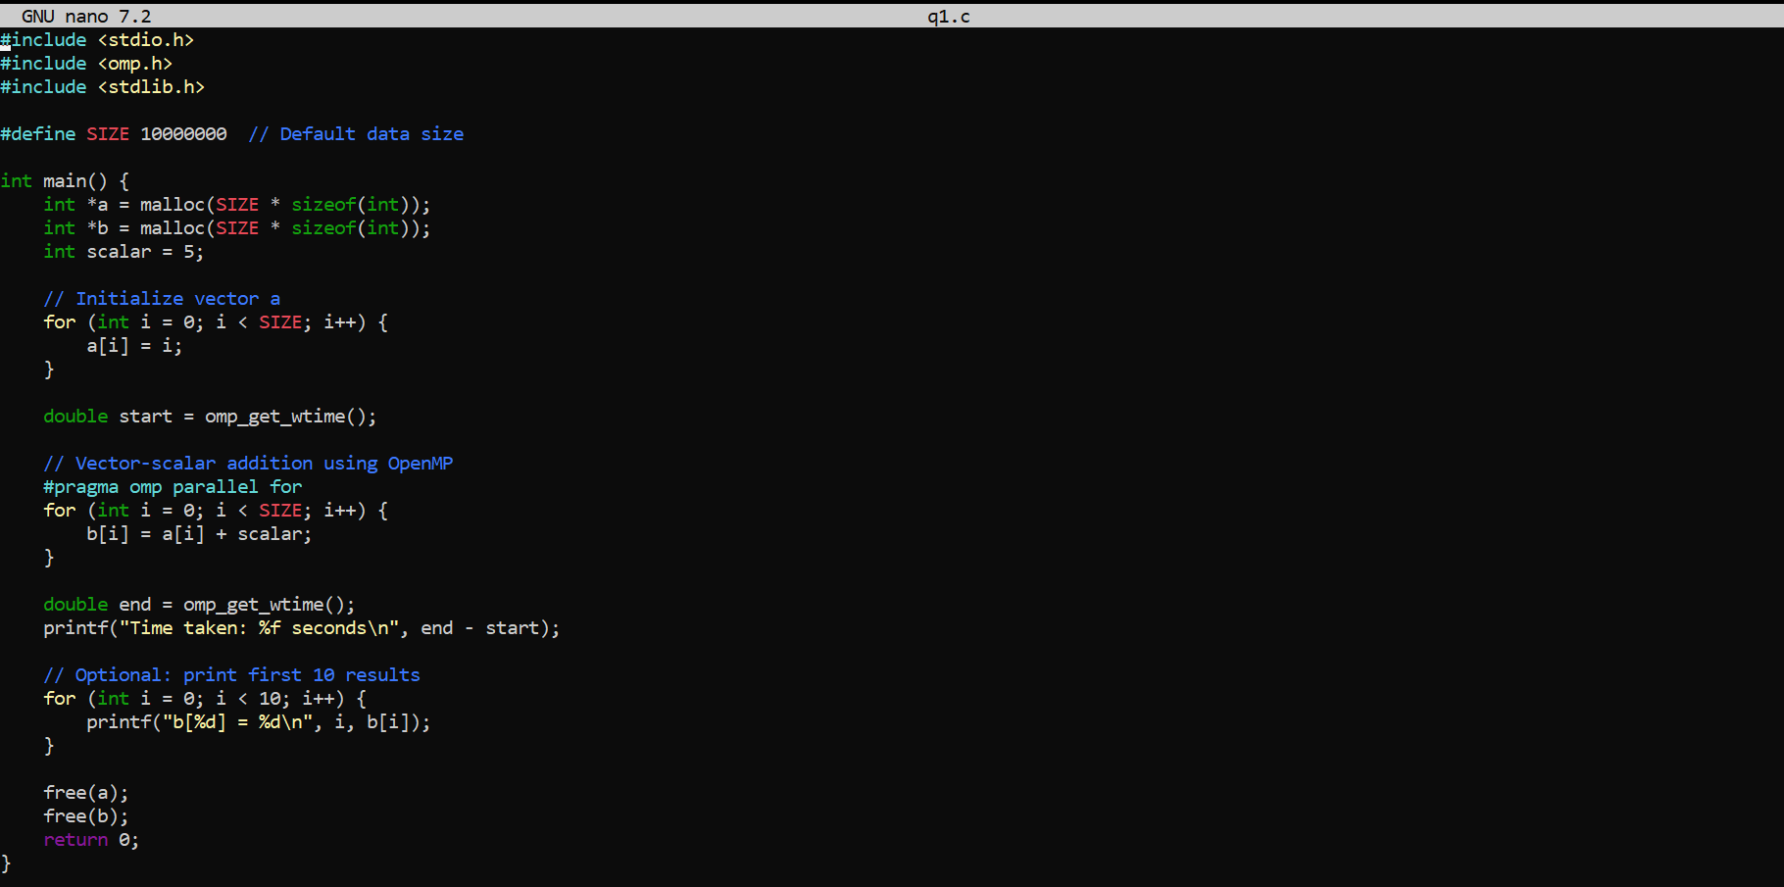

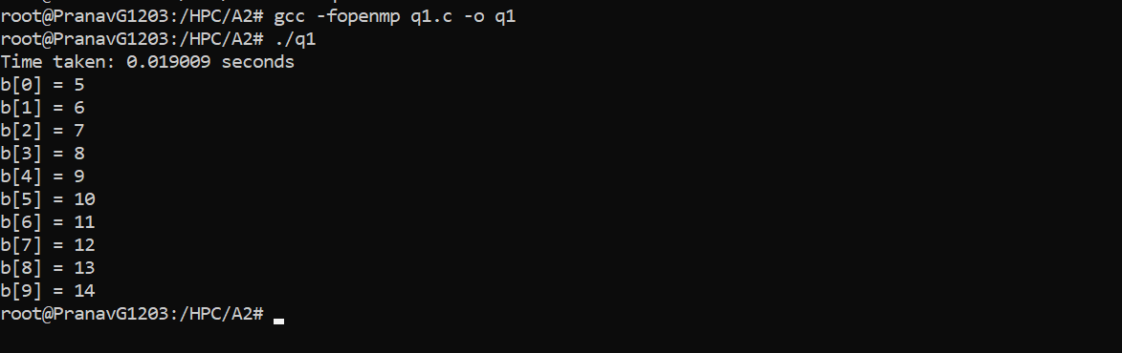

**Information:**

• We used #pragma omp parallel for to distribute loop iterations across threads.

• The scalar value is added to each element in the vector a to produce vector b.

**Analysis:**

• Performance improves with higher thread count due to parallelism.

• Diminishing returns may be observed as thread count exceeds core count.

• Optimal performance for large SIZE and up to physical core limit.

**Problem Statement 2:**

**Screenshots:**

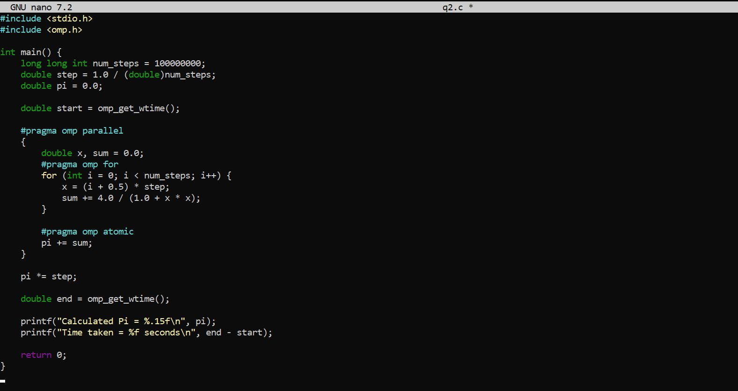

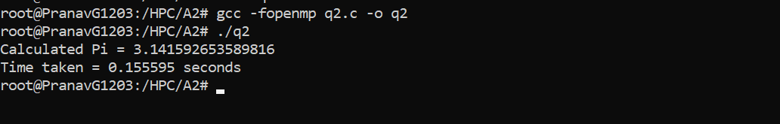

**Information:**

• Integration method used: Riemann sum approximation.

• Work is divided among threads using #pragma omp for.

• #pragma omp atomic ensures correct accumulation of partial sums.

**Analysis:**

* More threads improve performance by parallelizing the loop.
* Pi value remains consistent, accuracy depends on num_steps.
* Best speed-up is achieved with high num_steps and cores ≤ physical cores.

**Github Link: <https://github.com/Ganesh-Chavhan/HPC_LAB>**

**<https://github.com/Ganesh-Chavhan/HPC_LAB/tree/main/A2>**